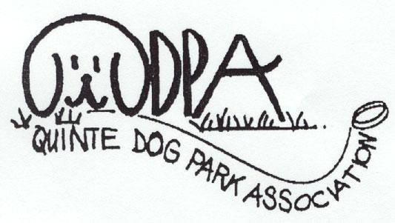
QUINTE DOG PARK
ASSOCIATION

Our “Pooch Path” at the Quinte Conservation area (corner Wallbridge-Loyalist Rd and hwy 2) has been open since August. More and more people bring their dogs to walk the trail and play with the other dogs. If you don’t think that dogs can smile, you need to see their faces when they get to the trail and run to catch up with their “friends”.

Shortly, the trail will be signed with park rules, and there will be pickup bags provided and a “digester” installed for these bio-degradable bags. Please keep the trail clean by picking up after your dog.

You may also use the main trail for longer walks but your dog must be on leash. PLEASE do not use the main trail during cross-country skiing season. The Conservation Authority built us this trail at their expense to preserve the main trail for skiers during the winter.

The trail comes close to the railway line. Put your dog on lead when a train approaches until you are certain your dog will not be “spooked” by the noise.

c/o Quinte Conservation, 2060 Old Hwy # 2, RR # 2, Belleville, Ont K8N 4Z2
http://www.quintedogpark.com

Off Leash Areas in Belleville

Off-Leash Dog Trail

Contents:

• Off Leash areas in Belleville

• Off Leash Dog Trail

• Dog Park at East Zwicks

- Membership Benefits
Congratulations to all of us for the progress we have made in the past six months to establish off-leash areas in the Quinte area so we can exercise our dogs (and ourselves) by walking with our dogs while they run and play off-leash.

At this time, we have an off leash trail (unfenced) at the Quinte Conservation area at the corner of Wallbridge-Loyalist Road and Highway 2, and on September 10th, the Belleville City Council approved the construction of a three acre fenced dog park to be located at East Zwicks park. Details of these two areas are given in this newsletter.

Why does Belleville need off leash dog areas? Many breeds of dogs require more exercise than they can get from a walk around the block on lead. For this reason, many people use the city parks to let their dogs run free, even though it is against the law not to have your dog on a lead ANYWHERE except for private property. As well, if a dog is running off leash, they may make a mess in the field off the path which is difficult to find and clean up (especially in the snow). Many other people use the parks, and some are frightened of dogs and deserve to be able to walk in the parks without being approached by a strange dog, no matter how friendly that dog may be, and without having their children fall in dog dirt in the field.

An off-leash area solves both these problems. Friendly dogs and their owners can walk and socialize with each other without worrying about bothering other park users. These areas will have pickup bags provided and garbage pails, and peer pressure will ensure that people pick up after their dog.

An off leash area has as many benefits for other park users as for the dog owners and their pets.

September 23, 2001
Volume 1, Issue 2
If your dog is behaving poorly, up his exercise.

Many dogs need an hour or more of hard running a day to behave like civilized pets.

Brian Kilcommons, Author
Good Owners, Great Dogs

Page 2 of 2
Quinte Dog Park Association

Member Pippin waiting to go to the dog trail
The City of Belleville has agreed to construct a three acre dog park for us in East Zwicks park. This new dog park will be located in an area south of the Ramada Inn. It will be immediately east of the parking lot in the wooded area not well used by other park visitors. Construction will begin early in October and it will be finished this fall.

This park will be totally enclosed with a four foot chain link fence. There will be a “double-gated” entry system, so that when you enter or exit the park, you will first enter a small enclosure, close the gate behind, un-leash your dog, and then open the next gate to enter the park.

There will be a small separate “small dog” area for those who are nervous about their small dogs interacting with the larger breeds. (Although in my experience, the small dogs can take care of themselves!) The city will be laying wood clips all around the perimeter to form a walking path for us, while our dogs play amongst the trees and mounds. One area at the rear will be clear for those who like to throw a ball or a Frisbee.

The Dog Park Association members have met to establish rules for this dog park. You can see them by visiting our web site at http://www.quintedogpark.com and clicking on “Dog Park Etiquette”. The city will be reviewing the success of this dog park after one year. It is important that we obey the rules and keep the park safe and clean. Members of the Dog Park Association will be monitoring the park during the first few months to welcome new visitors and make sure the rules are followed.



Dog Park at East Zwicks

If you are already a dog park association member, thank you for your support. If you are not a member and plan to use our off leash areas, please consider joining our association. The membership fee is only $10 per year for one dog. For this membership fee, I will keep you up to date on our off leash areas, and other dog parks throughout Canada and the United States. You will also receive a membership tag for your dog, and a listing on our web site (http://www.quintedogpark.com). If you send me a picture of your dog, I will put his picture on the site as well.

The cost of the fence for the dog park at East Zwicks park is $15,000 which we must re-pay over five years. We plan to get corporate sponsors in exchange for advertising at the park, and to hold fund raising events ie. barbecues, garage sales, dog washes etc. If you enjoy these off-leash areas, please participate to help pay off this debt and to get funds to improve the park.

You may pickup a membership form at the Quinte Conservation office, or by sending me an e-mail to jwmoore@sympatico.ca, or by calling my office at 966-3070.

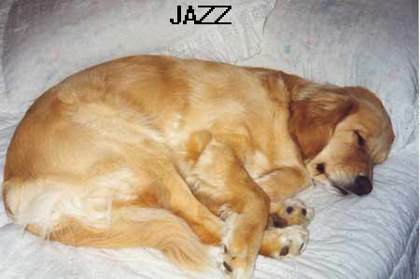

Member Jazz after his visit to the dog trail

Membership Benefits

"Dog walkers are legitimate park users.

Like soccer, tennis and softball players, they deserve a place to enjoy their chosen form of recreation"
Let’s work together to make our leash free area a success

